Design Spec for React Bug Application

Requirements:
1: create the list of problems and show them in the sidebar
- Scrollable sidebar
- Clickable/selectable
- Show all the params
- Progress-bar (good to have)
2. Editor section
- Make the editor section
- Research editor component

Design Spec:
https://react-bug-gym.work-debraj.chatgpt.site/
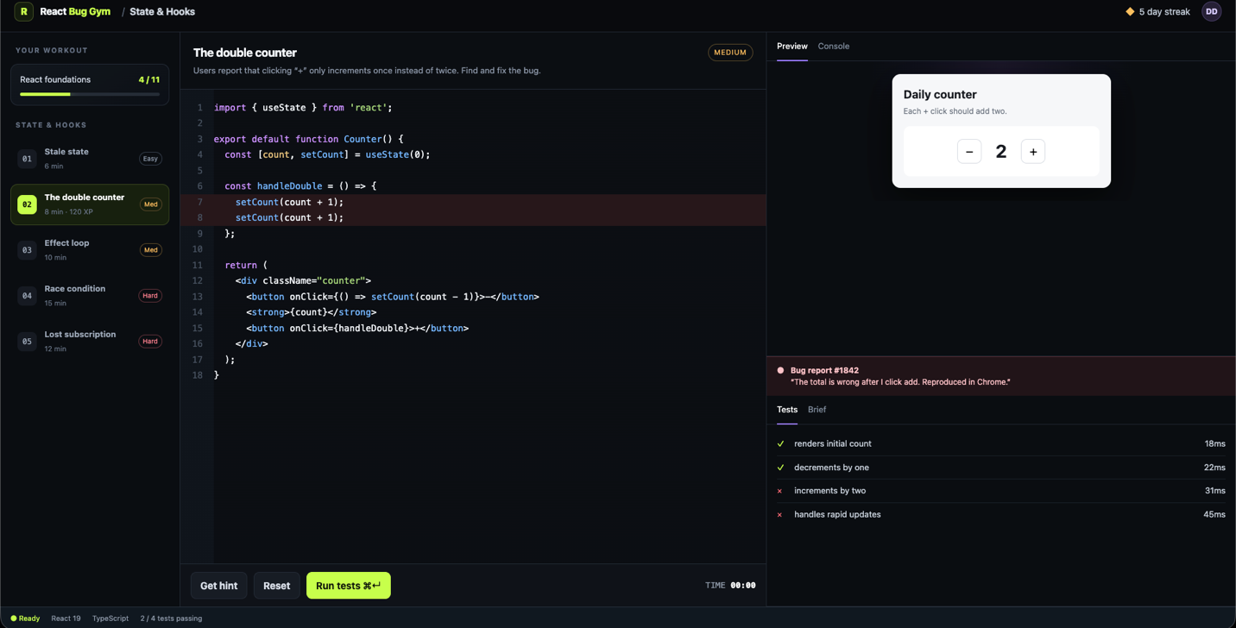

Component building suggestions:

React Bug Gym area | Recommended component
Challenge navigation | shadcn Sidebar
Editor/preview columns | shadcn ResizablePanel
Preview, console and tests | shadcn Tabs
Hint window | shadcn Dialog
Challenge difficulty | shadcn Badge
Course completion | shadcn Progress
Run/reset controls | shadcn Button
Success notification | shadcn Sonner
Keyboard shortcuts | shadcn Kbd
Icons | Lucide React
Code editing | Monaco Editor

